Hybrid Automation Framework
(Java, Selenium, TestNG, Maven & Page Object Model)
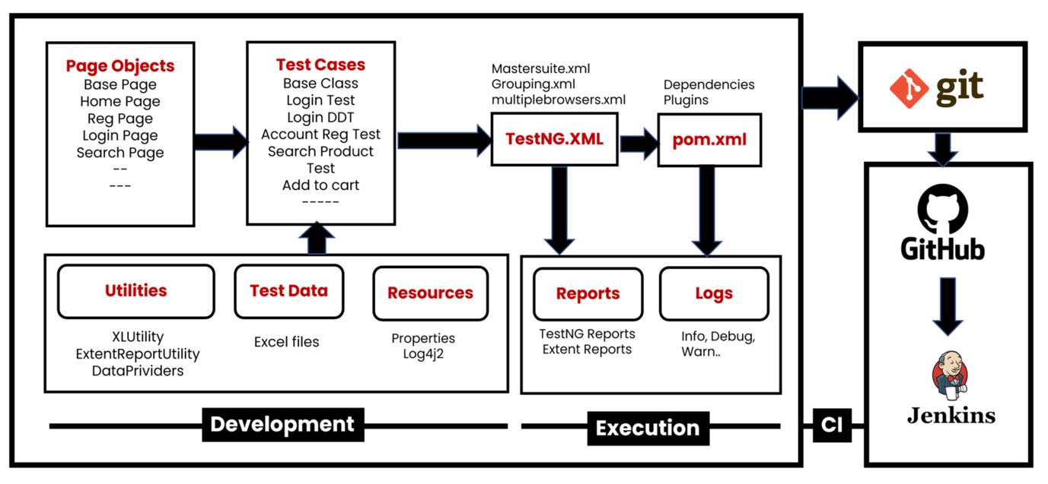

Create a new Maven Project
Add required dependencies in pom.xml (Please check links below)
https://mvnrepository.com/artifact/org.seleniumhq.selenium/selenium-java https://mvnrepository.com/artifact/org.apache.poi/poi https://mvnrepository.com/artifact/org.apache.poi/poi-ooxml https://mvnrepository.com/artifact/org.apache.logging.log4j/log4j-core https://mvnrepository.com/artifact/org.apache.logging.log4j/log4j-api https://mvnrepository.com/artifact/commons-io/commons-io https://mvnrepository.com/artifact/org.apache.commons/commons-lang3 https://mvnrepository.com/artifact/org.testng/testng https://mvnrepository.com/artifact/com.aventstack/extentreports

Create Folder Structure
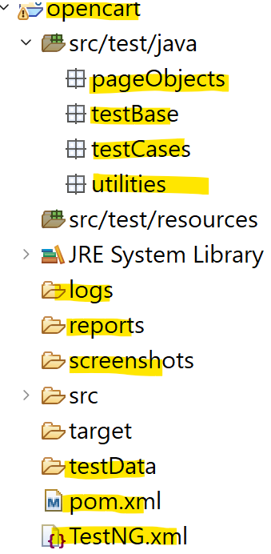
Development of Hybrid Driven Framework
1) Test case: Account Registration
1.1: Create BasePage under "pageObjects" which includes only constructor. This will be invoked by every Page Object Class constructor (Re-usability).
1.2: Create Page Object Classes for HomePage, RegistrationPage under pageObjects package. (These classes extends from BasePage).
1.3: Create AccountRegistrationTest under "testCases"
1.4: Create BaseClass under testBase package and copy re-usable methods.
1.5: Create re-usable methods to generate random numbers and strings in BaseClass.

2) Adding logs to test case (log4j2)
2.1: Add log4j2.xml file under src/test/resourses.
2.2: Update BaseClass.
2.3: Add log statements to AccountRegistrationTest.

3) Run Tests on Desired Browser/Cross Browser/Parallel
3.1: Create testng.xml file to Run Test Cases and parameterize browser name and OS to BaseClass →setup() method.
3.2: Update BaseClass →setup() method, launch browser based on conditions.
3.3: Maintain separate xml to run tests multiple browsers parallelly.
4) Read Common values from config.properties file.
4.1: Add config.properties file under src/test/resoures.
4.2: Update BaseClass →setup() method, add script to load config.properties file.
4.3: Replace hard coded values in Test Cases like url, username, password etc...
5) Login Test Case
5.1: Create and update page object classes. LoginPage, MyAccountPage – new classes HomePage – update by adding login link element
5.2: Create LoginTest
5.3: Add entry testng.xml
6) Data Driven Login Test
6.1: Prepare test data in Excel, place the excel file inside the testData folder.
6.2: Create ExcelUtility class under utilities package.
6.3: Update Page Object class MyAccountPage , add logout link element)
6.4 : Create DataProviders class in utilities package to maintain data providers for data driven tests.
6.5: Create LoginDataDrivenTest under testCases package.
6.6: Add an Entry in testng.xml file
7) Grouping Tests.
7.1: Add all test cases into specific group ( sanity, regression , master etc.).
7.2: Also add BaseClass methods setup() & teardown() to all groups.
7.3: Create separate TestNG xml file(grouping.xml) to run groups and include groups which we
want to execute.
8) Add Extent Reports to Project
8.1: Create ExtentReportUtility utility class under utilities package.
8.2: Add captureScreen() method in BaseClass
8.3: Add ExtentReportUtility (Listener class) entry in testng.xml file.
8.4: Make sure WebDriver is static in BaseClass, we refer same driver instance in ExtentReportUtility.
9) Run Failed Tests.
test-output→testng-failed.xml
10) Run Tests on Selenium Grid
Pre-requisite: Grid Standalone/Hub & Node setup (Refer the Grid Setup document)
10.1: Add execution_env=local/remote in config.properties file under resources folder.
10.2: Update setup() method in the BaseClass (capture execution environment from config.properties file then add required capabilities of OS & Browser in conditions).
10.3: Run the tests from testing.xml
11) Run Tests on Docker with Selenium Grid Environment.
** Refer the DockerSetup Document.

12) Run Tests using Maven pom.xml, Command Prompt & run.bat file.
13) Push the Code to Git & GitHub Repository
14) Run Tests using Jenkins.

